Catherine DeJager

ENGL 370

Friday, 2/22/19

Corpus Linguistics Project: Gender Pronouns in Historical Corpora

Question and strategy: How frequently is singular “they” (and other forms; e.g., “theirs”) used in comparison to other pronouns (“he”, “he/she”, “he or she”, “s/he”, “(s)he”)? I’m particularly interested in the usage over time, so I plan to look at TIME corpus to see frequency. I will also look for noun collocates before they/their to find the antecedents to see whether the most common antecedents are singular or plural. I may look at KWIC.

Hypothesis: singular “they” becomes more frequent later, so “they” is used more frequently in later decades.

I tried to find usage of singular “they”, but ran into some issues. My first idea was to search for singular noun left collocates of “they” (occurring up to 4 words before “they”). I thought those collocates might be antecedents of “they”, but this is not the case.

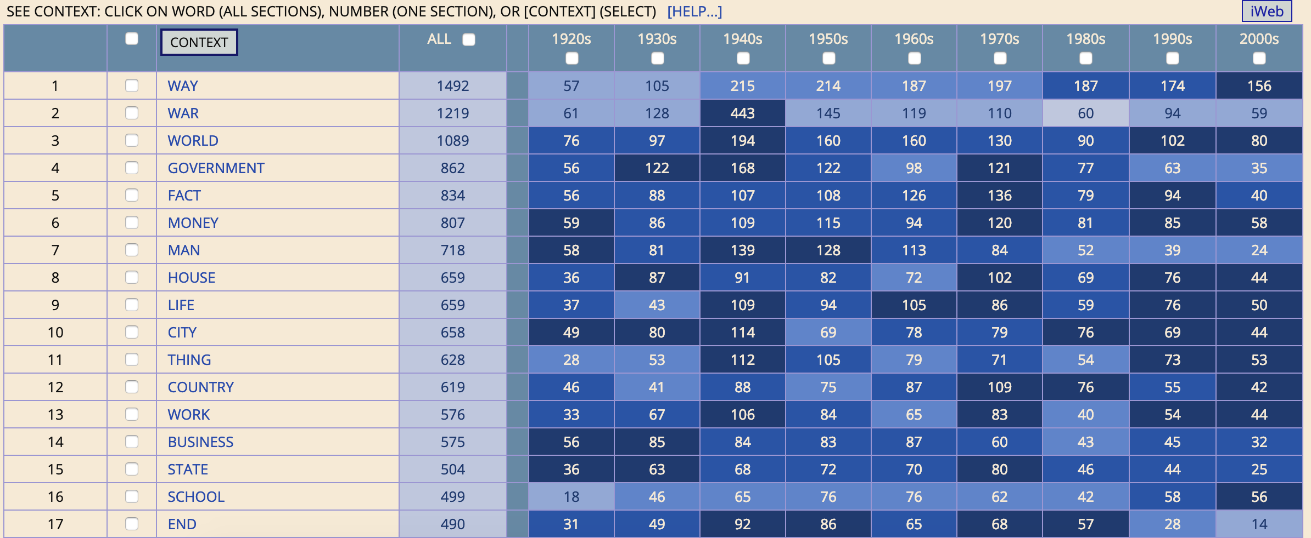

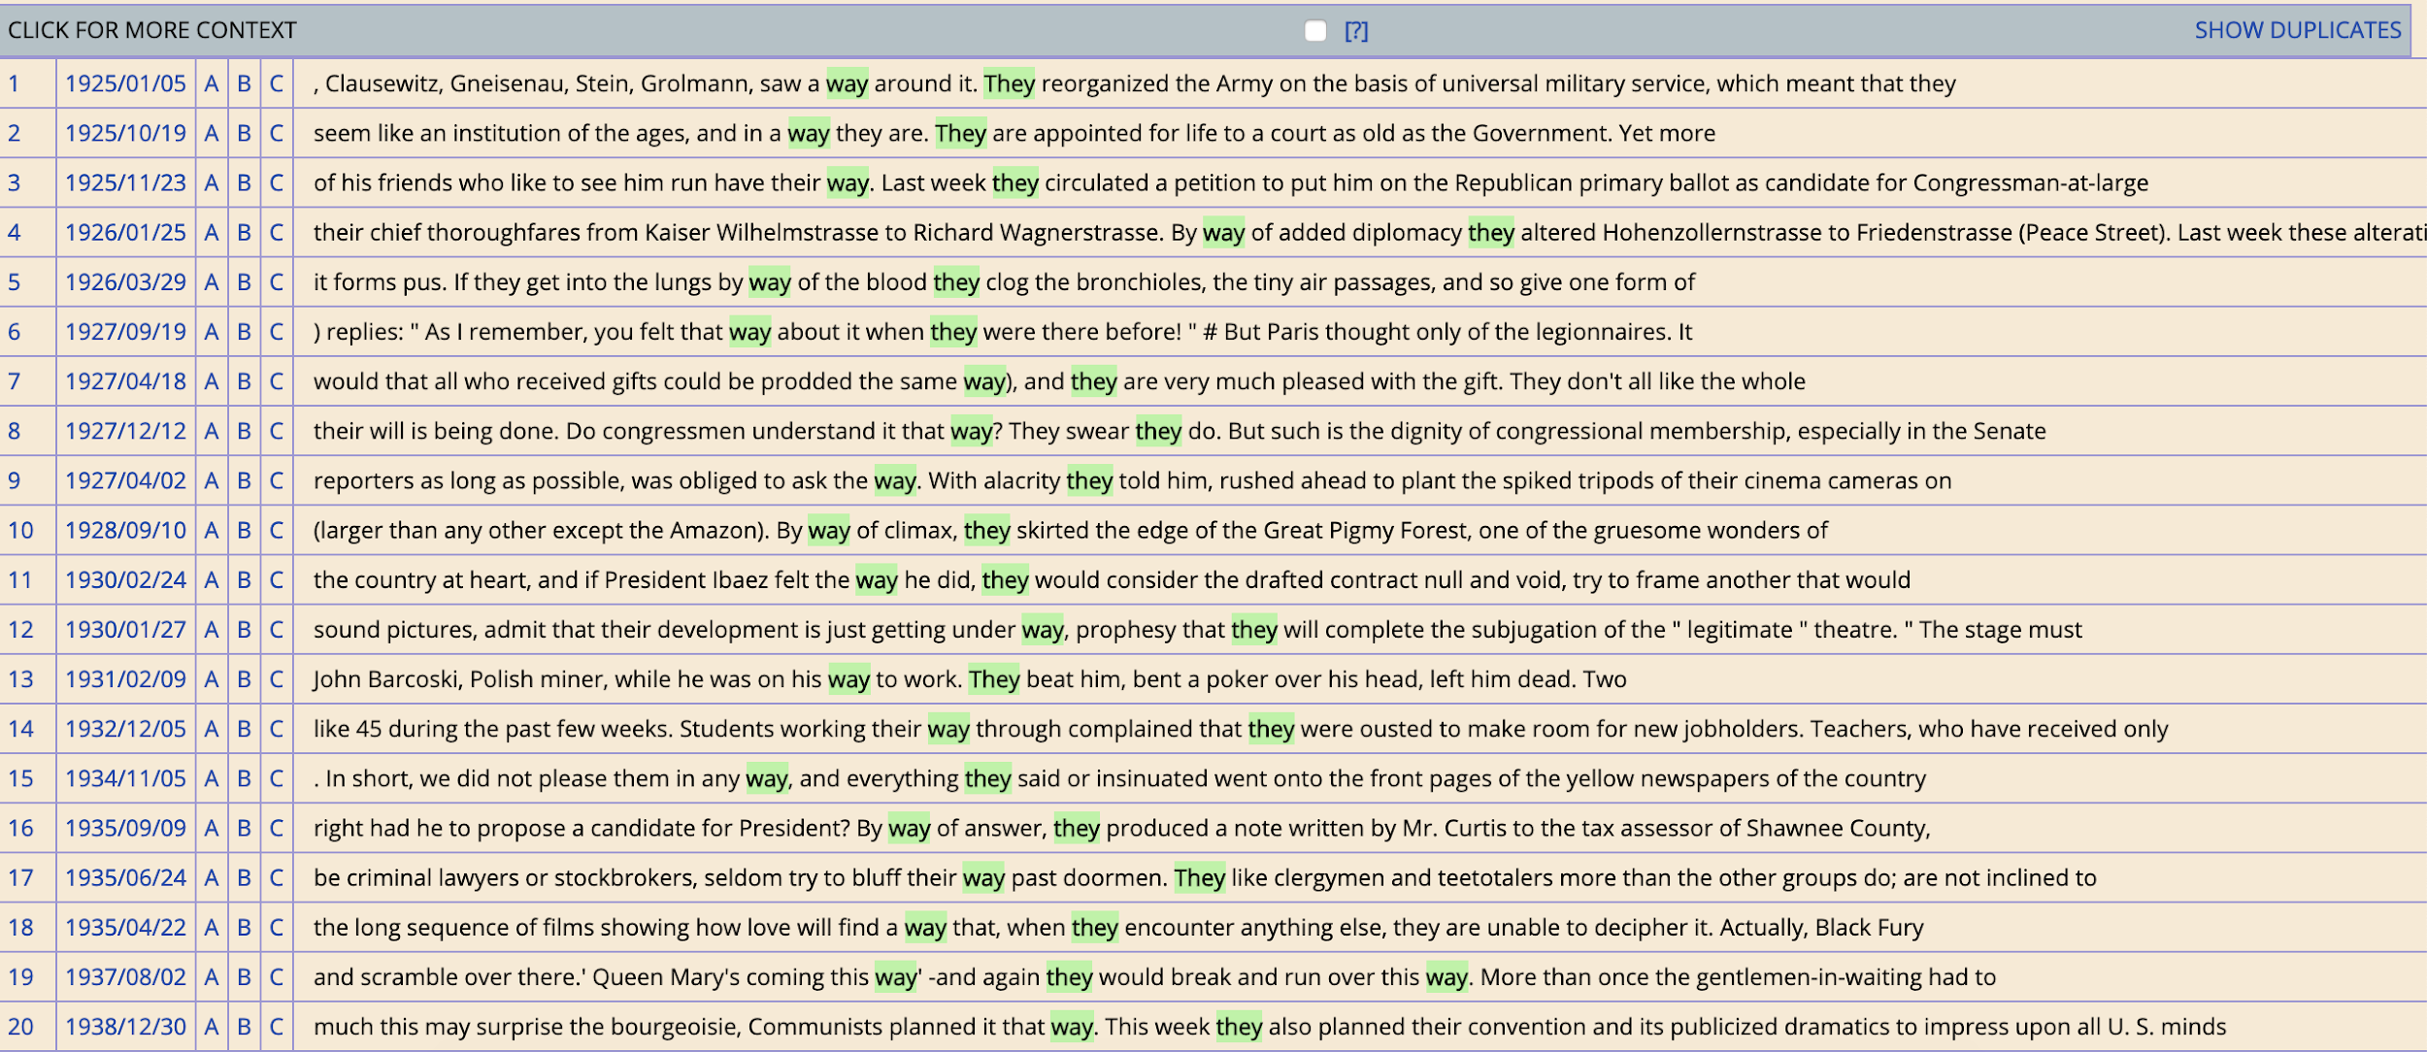

The singular nouns collocate with “they” are everyday things about which one might talk. And those nouns can be from previous sentences and thus not be related to people. I did take a moment to notice “he or she” used to refer to a person of unknown gender by looking at keyword in context. Politicians, students, patients, stockholders, etc. are referred to as “he or she”.

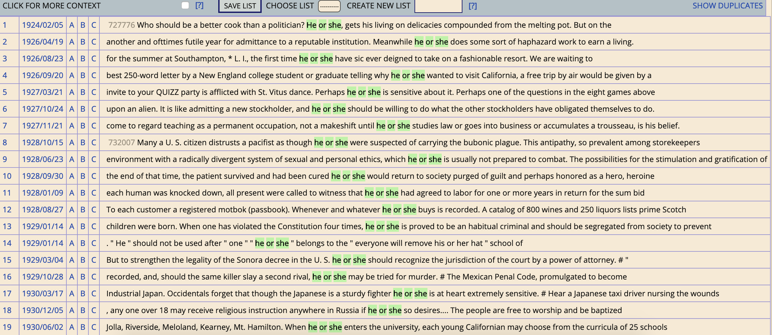

So I moved on to a more quantitative analysis, trying instead to find trends in personal pronoun usage over time. My intuition is that previously, people talked about men more often than other genders and that male pronouns were used to refer to people whose gender is unknown. So can I see a decrease in male pronouns correlated with an increase in other personal pronouns?

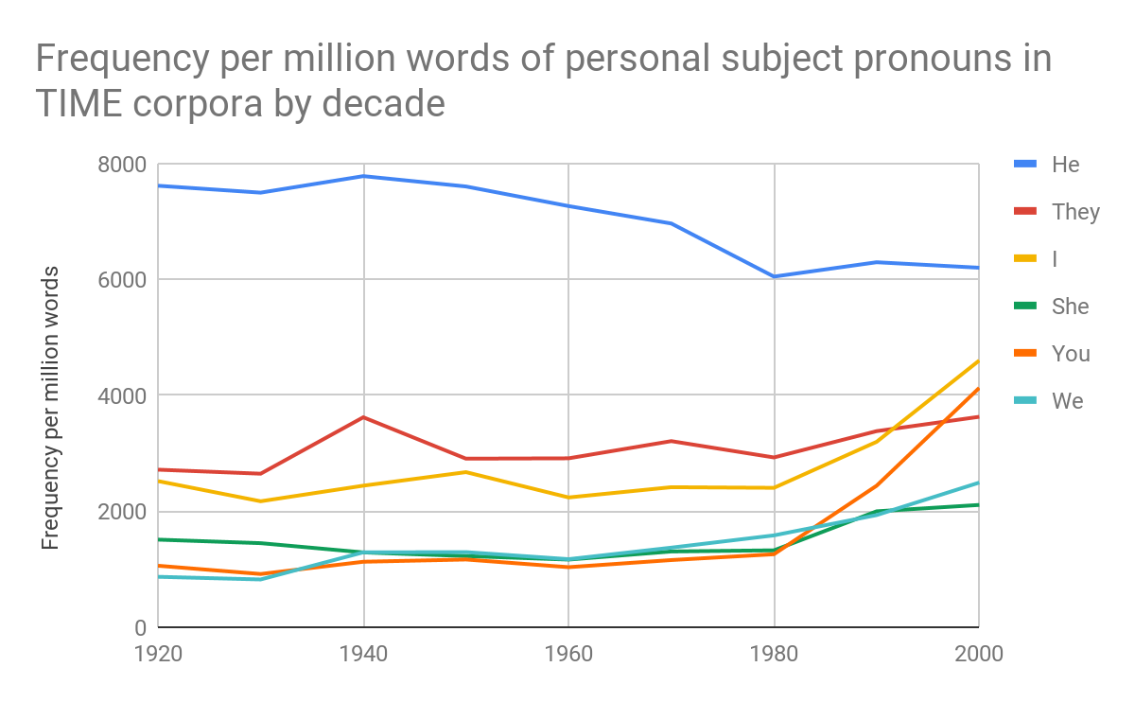

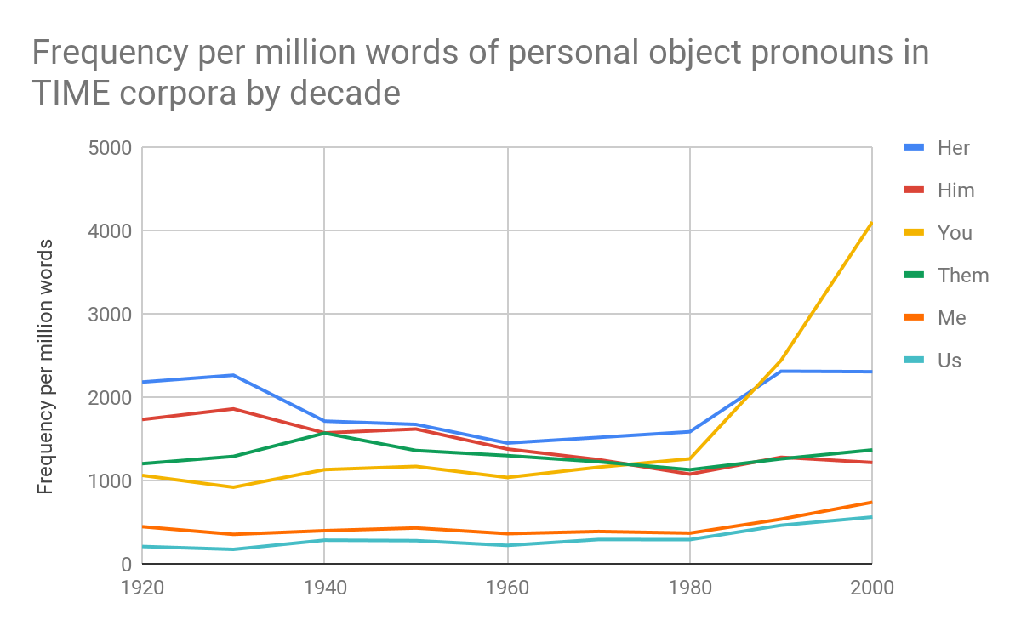

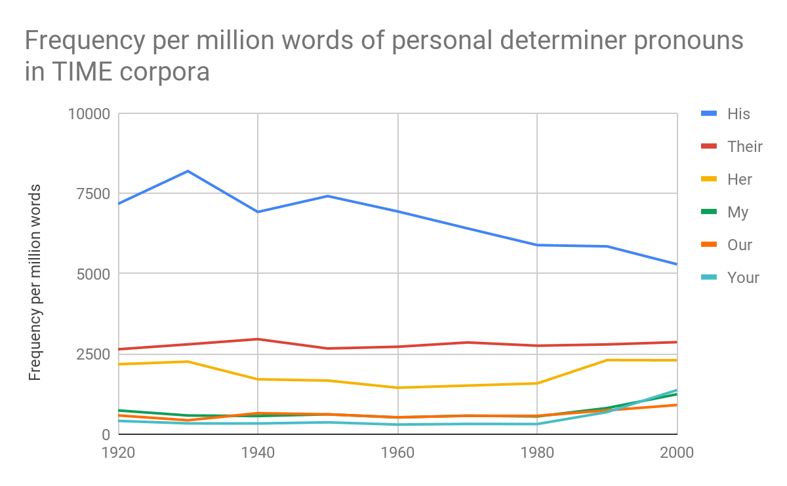

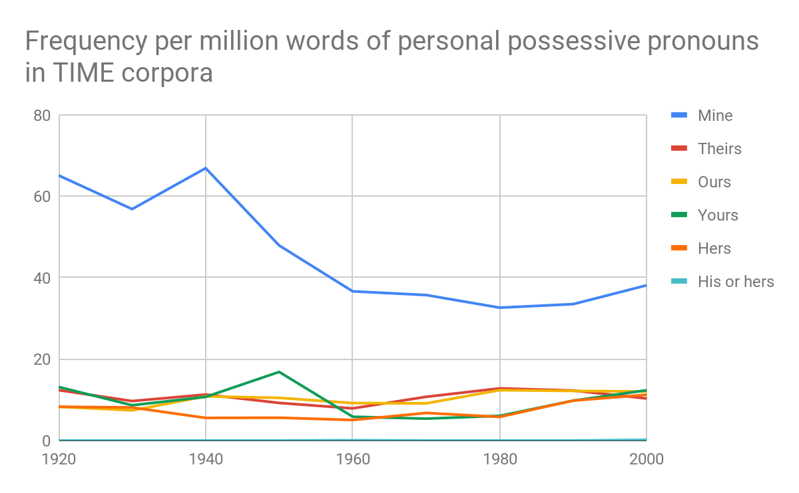

“His” was so frequent it messed up the scale of the chart, so I had to remove it.

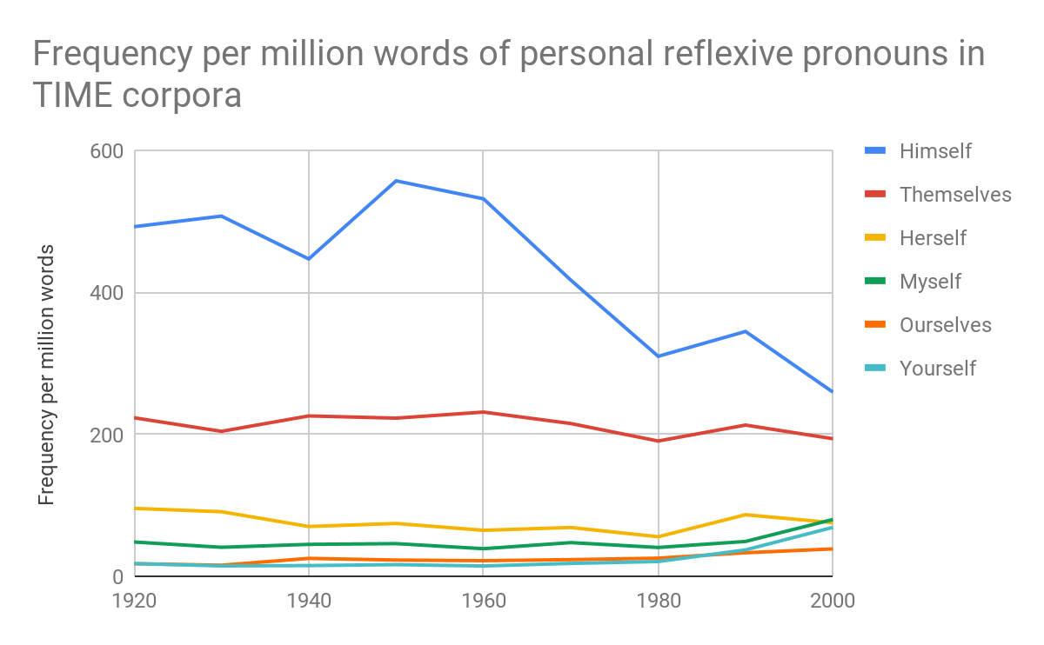

I noticed that in general, female pronouns increased from 1980 to 2000. Male pronouns decreased over time. “They” increased over time, particularly where “he” decreased.

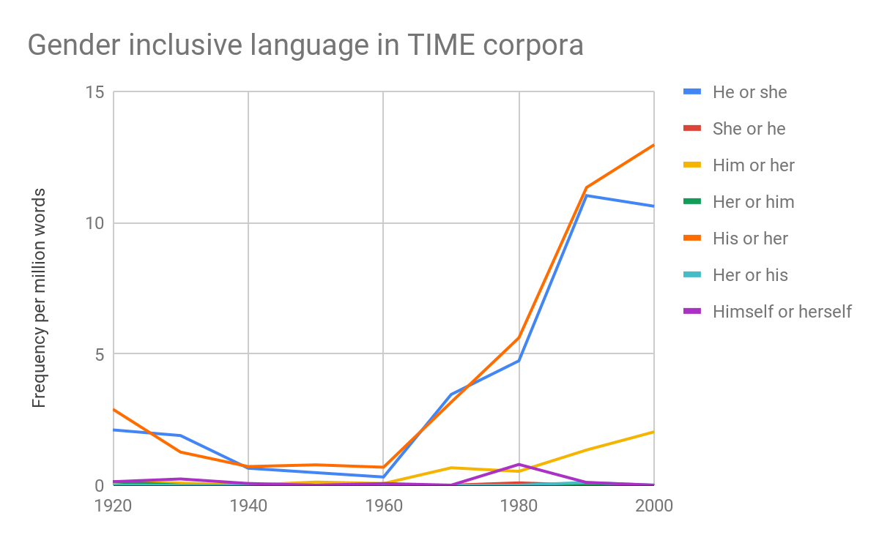

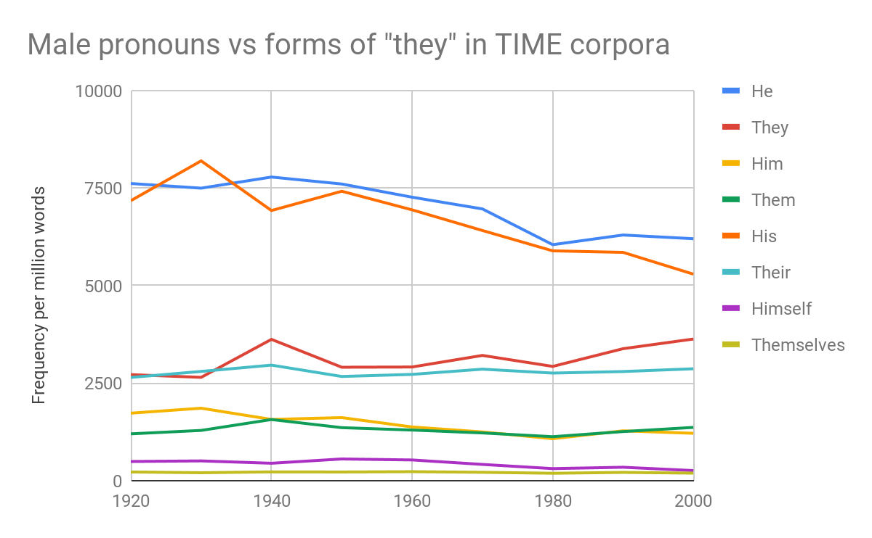

Examination of the above charts shows that gender inclusive alternatives (e.g., “they”) rose starting in 1970, which is when male pronouns (particularly “he” and “him”) were declining. This makes sense because second-wave feminism started in the 1960s. In 1980, feminists Casey Miller and Kate Swift published *The Handbook of Nonsexist Writing*. Eventually this cultural change passed on to the language of TIME magazine. I wondered whether this trend could also be seen in COHA, so I searched that and made charts as well.

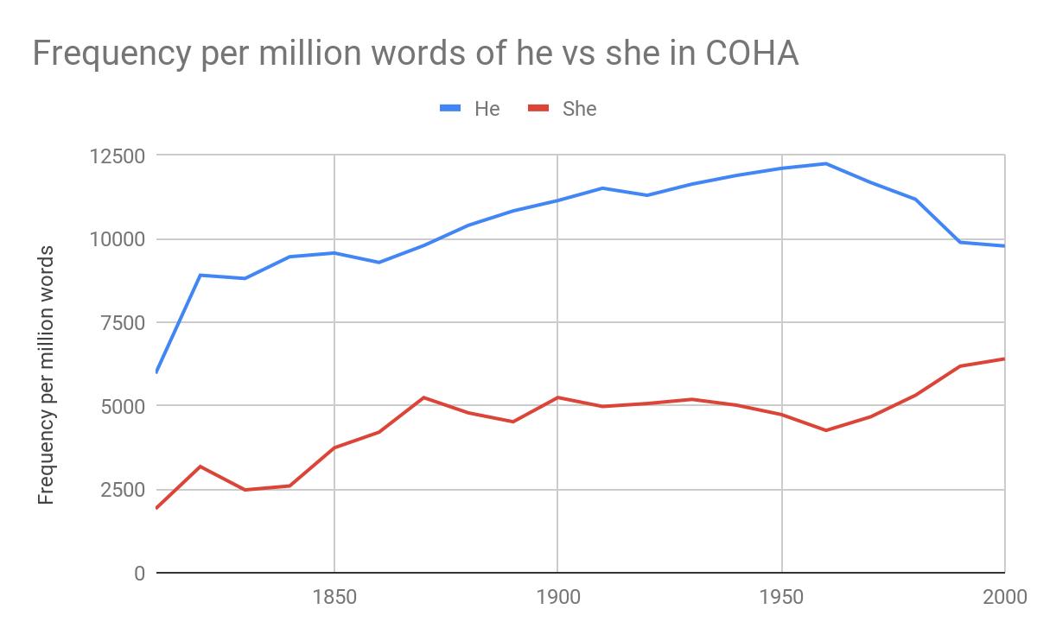

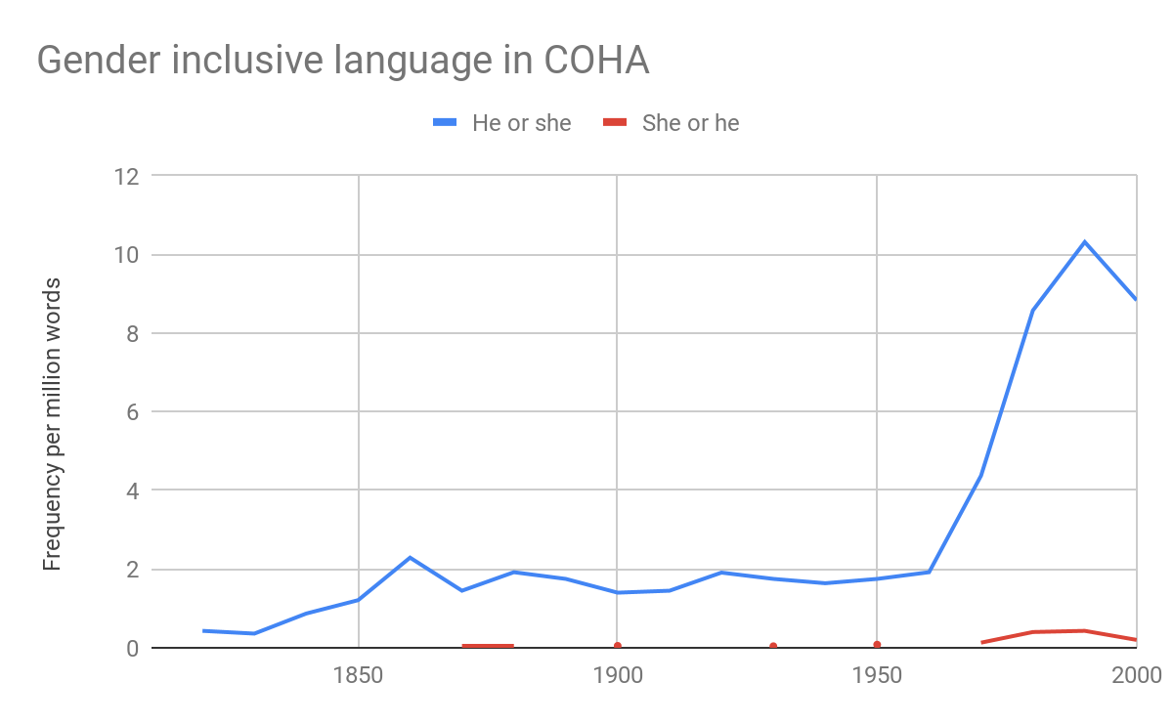

The same trend can be observed in COHA: starting in about 1970, we see a decrease in male pronouns, an increase in female pronouns, and an increase in gender inclusive language like “he or she”. So while I wasn’t able to answer my initial question, I did find some interesting information.

As I did research for my presentation on Gender Neutral Language for my History of the English Language class, I found a report on gender language (summary at <https://www.biblica.com/articles/collins-report-gender-language-english/>, full findings at <https://www.thenivbible.com/wp-content/uploads/2015/02/Collins-Report-Final.pdf>). That report gave me the idea to search for gender-neutral nouns (e.g., makind vs humankind). Results are shown in TIME and COHA.

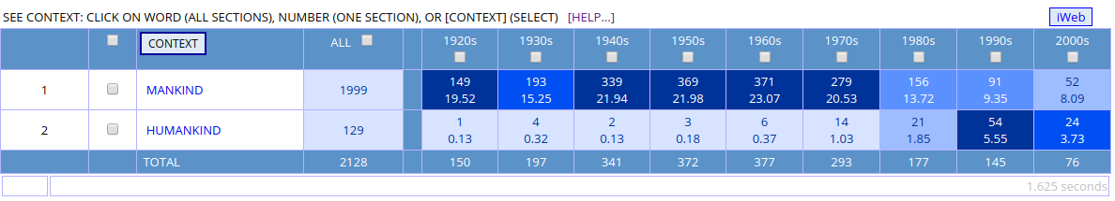

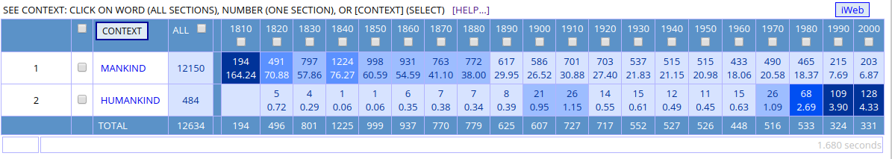

As can be seen from a variety of sources, written English language has become more gender inclusive over time, especially starting around 1970 as the influences of second-wave feminism began to take root.

(If you are interested in seeing the raw data that went into the graphs, you can see the spreadsheet at <https://docs.google.com/spreadsheets/d/1kYMAxZLh7wsDm0pHyoHzO46LxOcn1zl6VWhnelDn-1k/edit?usp=sharing>. However, I figured this report was long enough as is, so that’s why I’ve provided a link to the spreadsheet instead of copying and pasting all the content.)